BACKGROUND
You work as an analyst at a Security Operation Center (SOC) for a medical research facility specializing in nemotodes. Alerts on traffic in your network indicate someone has been infected.
LAN segment details:
- LAN segment range: 10.11.26[.]0/24 (10.11.26[.]0 through 10.11.26[.]255)
- Domain: nemotodes[.]health
- Active Directory (AD) domain controller: 10.11.26[.]3 - NEMOTODES-DC
- AD environment name: NEMOTODES
- LAN segment gateway: 10.11.26[.]1
- LAN segment broadcast address: 10.11.26[.]255
TASK
- Write an incident report based on malicious network activity from the pcap and from the alerts.
ALERTS
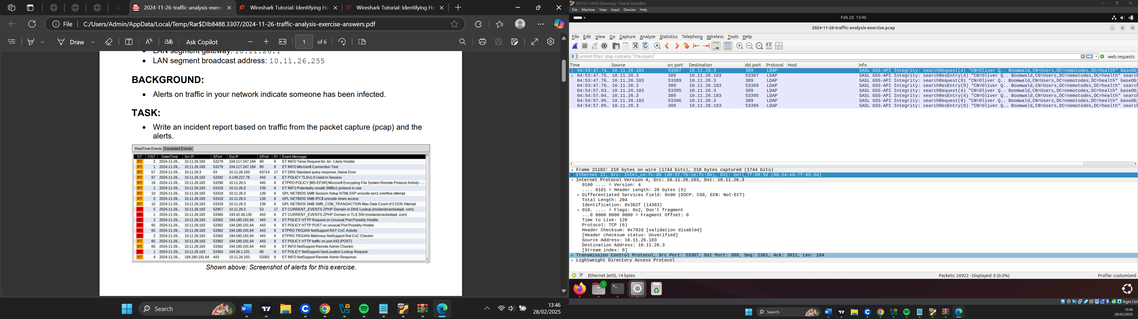

INVESTIGATION:
Top Talkers:
193.42.38.139 – This IP address resolved to (modandcrackedapk[.]com) which is a malicious site at 4:50:19 and it sends payloads to host.
213.246.109.5 – This IP address resolved to the host classicgrand[.]com, this site appears clean but has a malicious file communicating with it. There is an exchange of payload between this domain and the host. At 4:50:11
173.222.49.101- This host is related to akamai, and the host makes a connection for some Microsoft services.
52.113.194.132- This resolved to MSFT a Microsoft domain but has communications with malicious files
10.11.26.3- This is the domain controller.
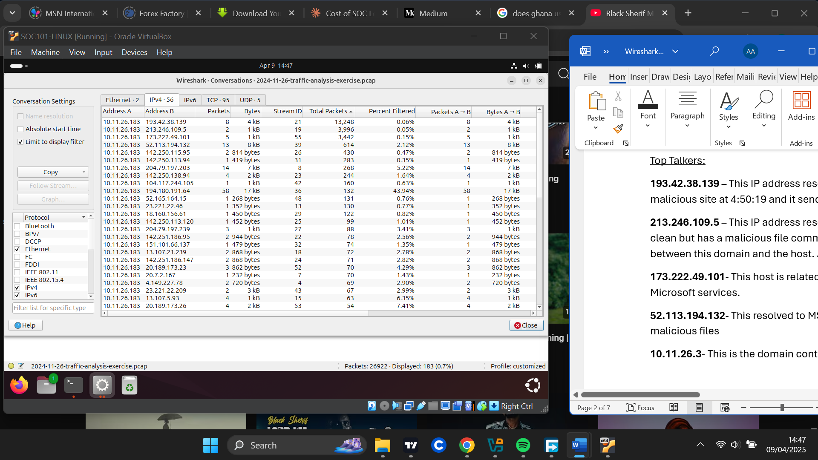

Suspicious Web connections:
- (at 4:49:38) The host makes a GET request to the Ip address 104.117.247.84 on port 80 which is related to akamai technologies. It makes a request for a connecttest.txt file. This file has a lot of malicious execution parents making it very suspicious.
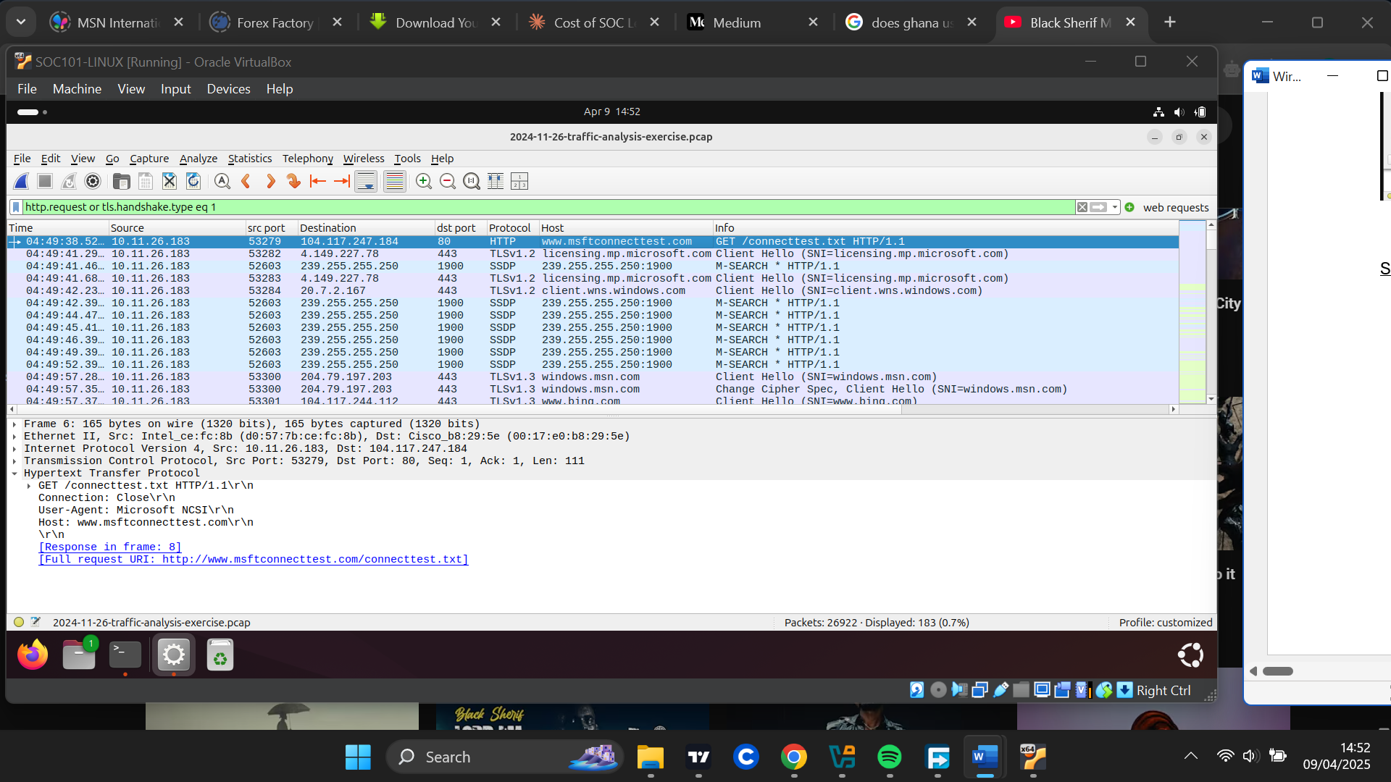

- (at 4:50:11) The host makes a request for “classicgrand[.]com” on port 443. This domain is legitimate but has communication with a known malicious file making it suspicious.

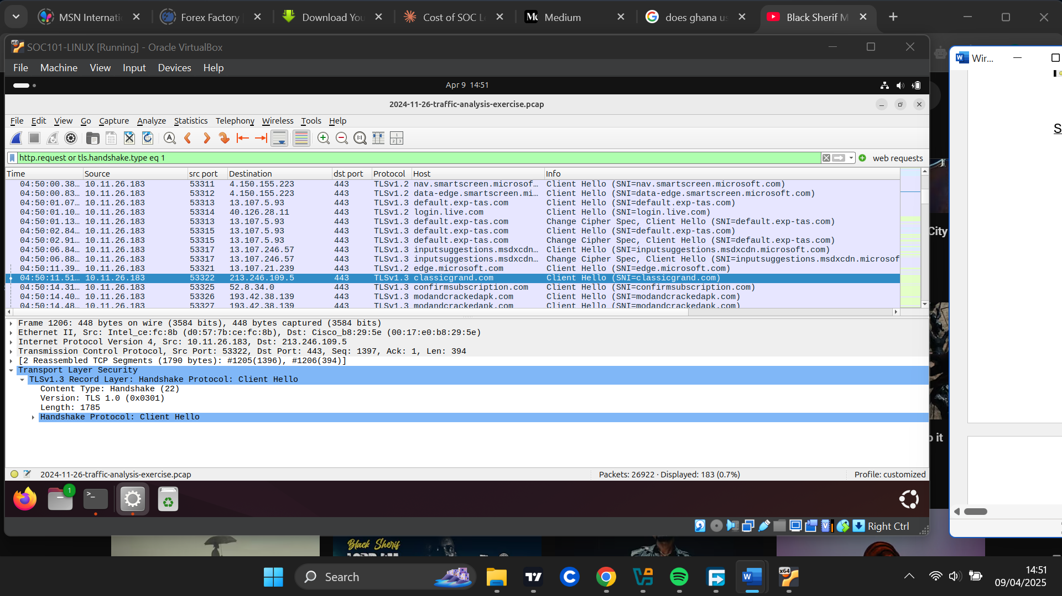

- (at 4:50:14) The host then makes a request for” modandcrackedapk[.]com” on IP address 193.42.38.139. This domain was found to be malicious with multiple security vendors flagging it malicious.
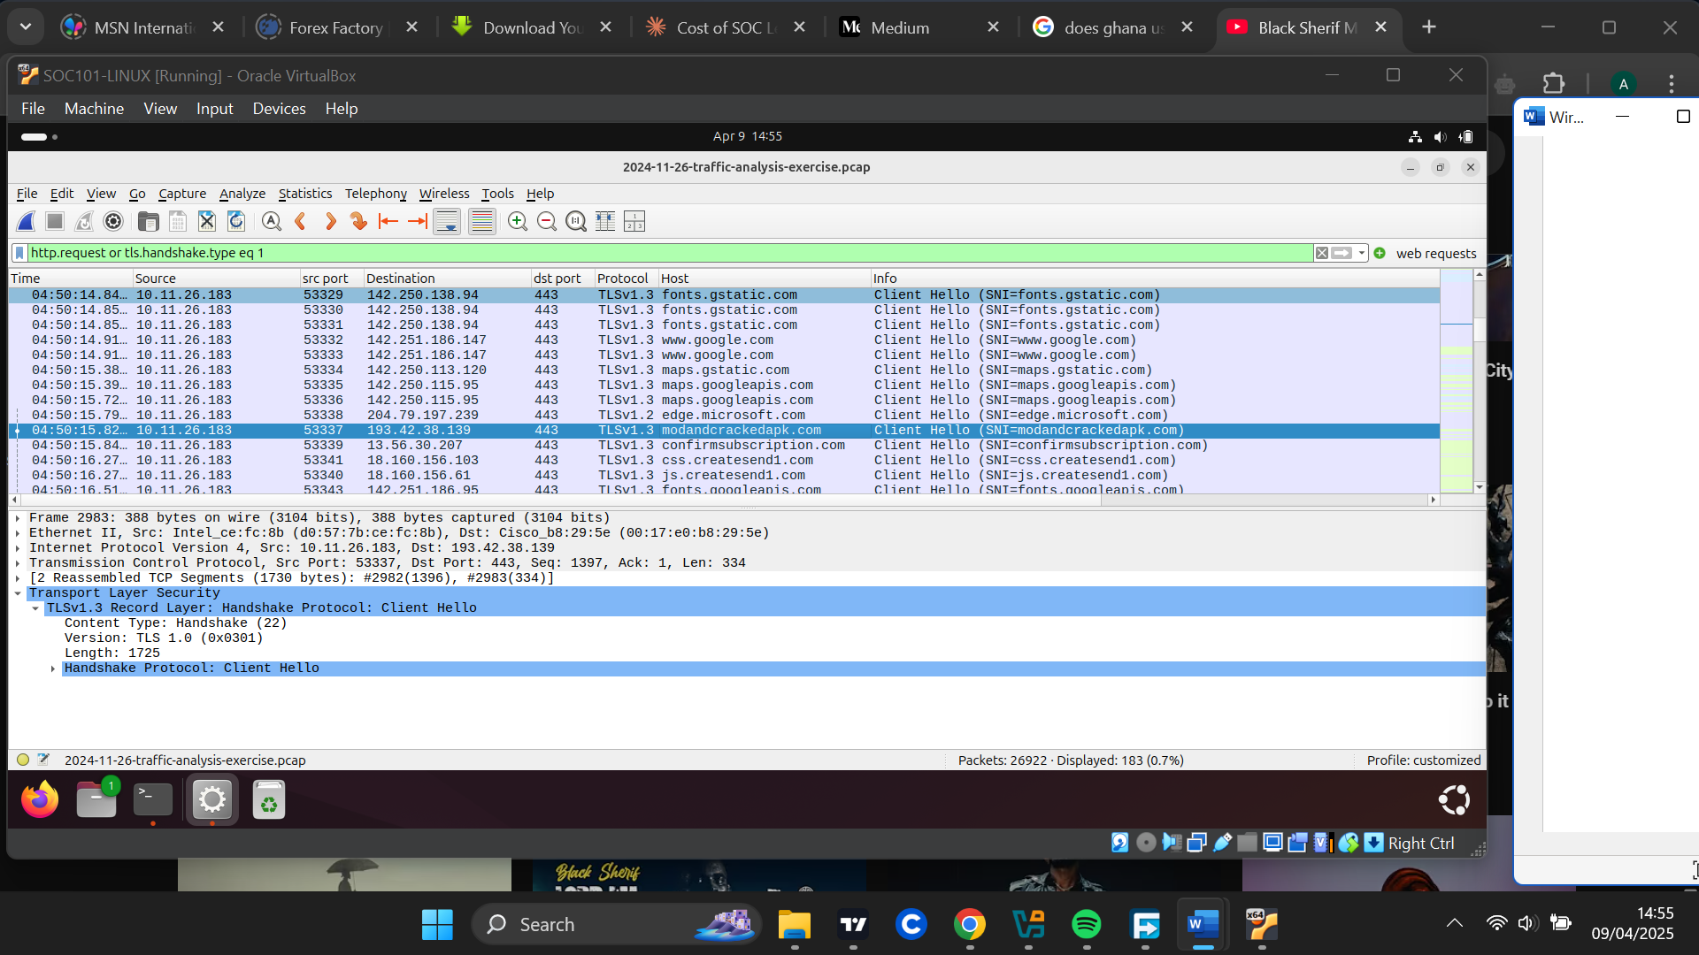
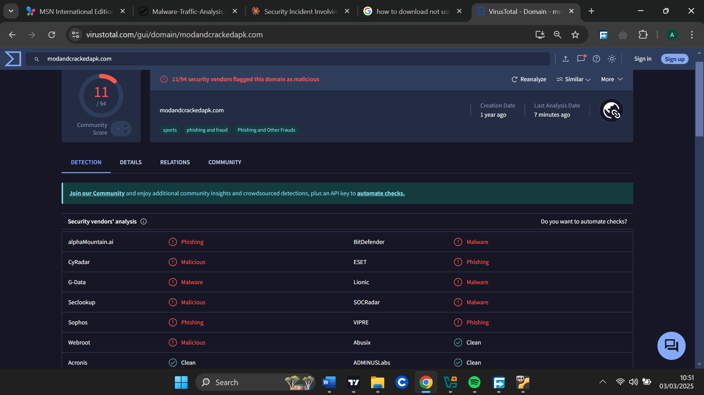

- (at 4:50:40) The host then makes a GET request to the IP address 104.117.247.99 (resolved to r10.0.lencr.org). This address is suspicious it has communication with lots of malicious files. The GET request contained a base-64 URL encoding making it suspicious.
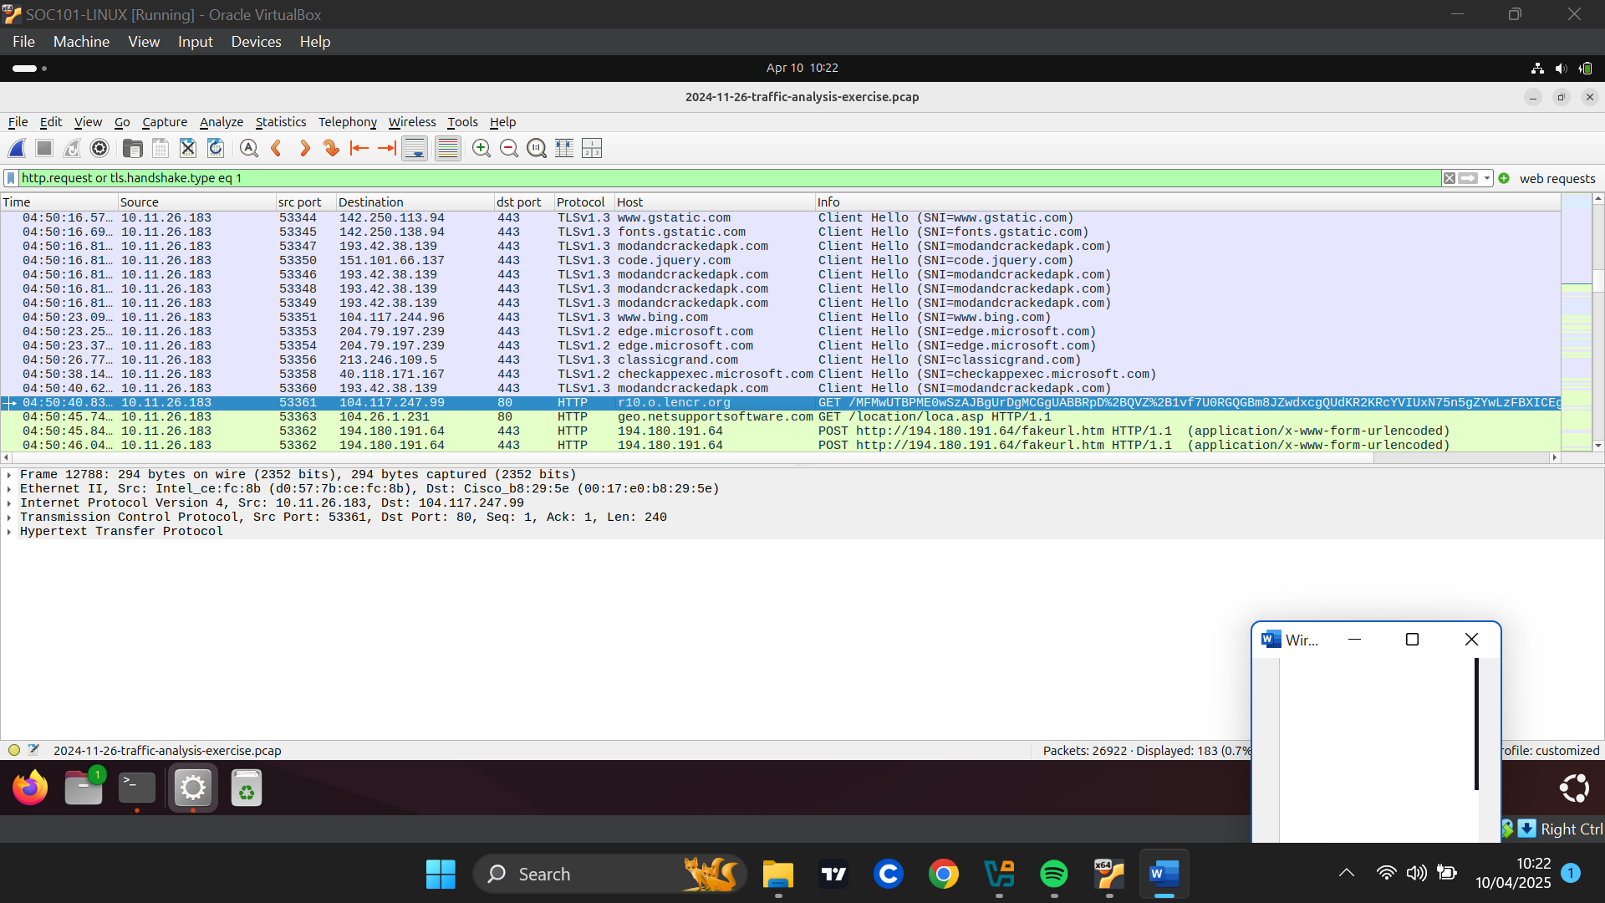

- (at 4:50:45) The host makes a request to 104.26.1.231 which resolved to (geo.netsupportsoftware[.]com) for “loca.asp” which is an (Active Server Page) from the “location “directory. This domain was found to be malicious .
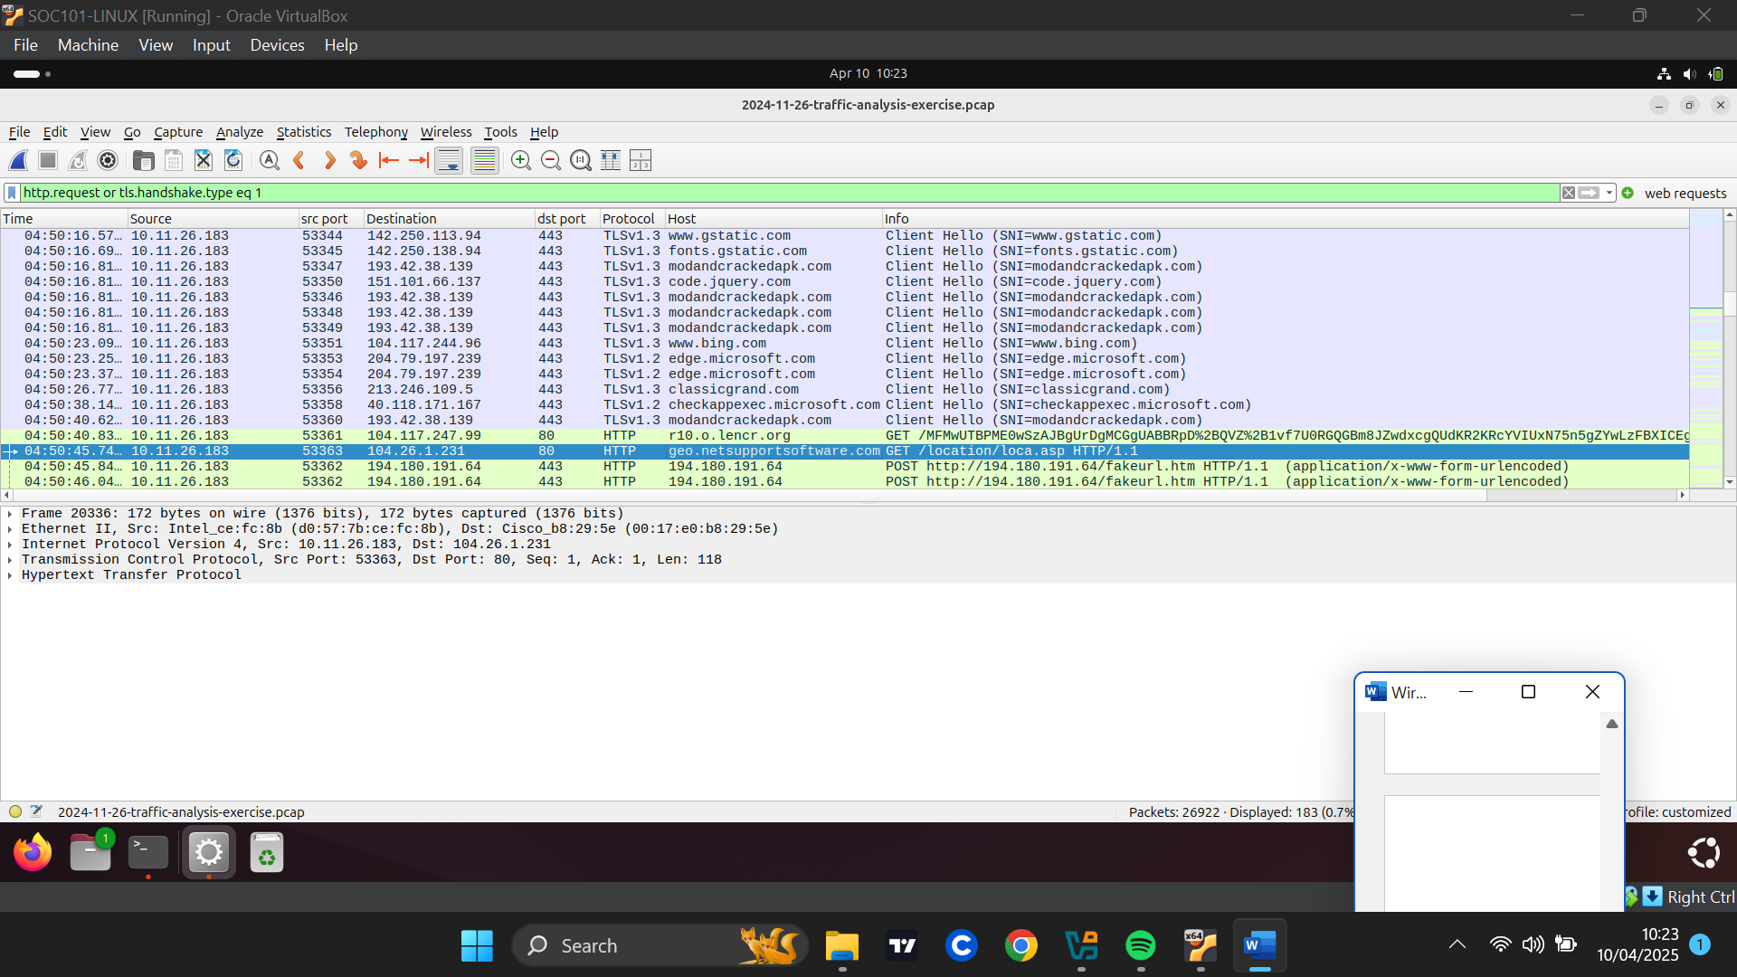
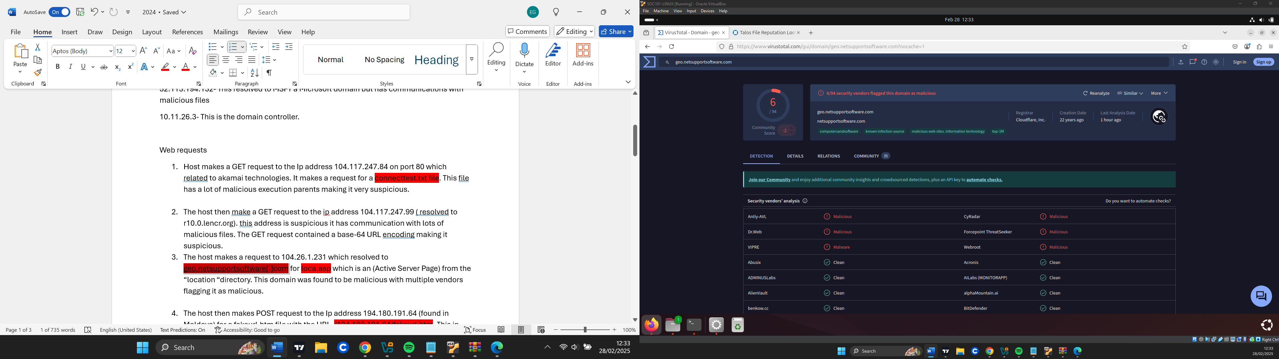

- (at 5:01:56) The host makes a GET request to the IP address 23.53.127.105 which resolved to (acroipm2.adobe[.]com) for a “Processmau.txt”. This file has relations with malicious execution parents.
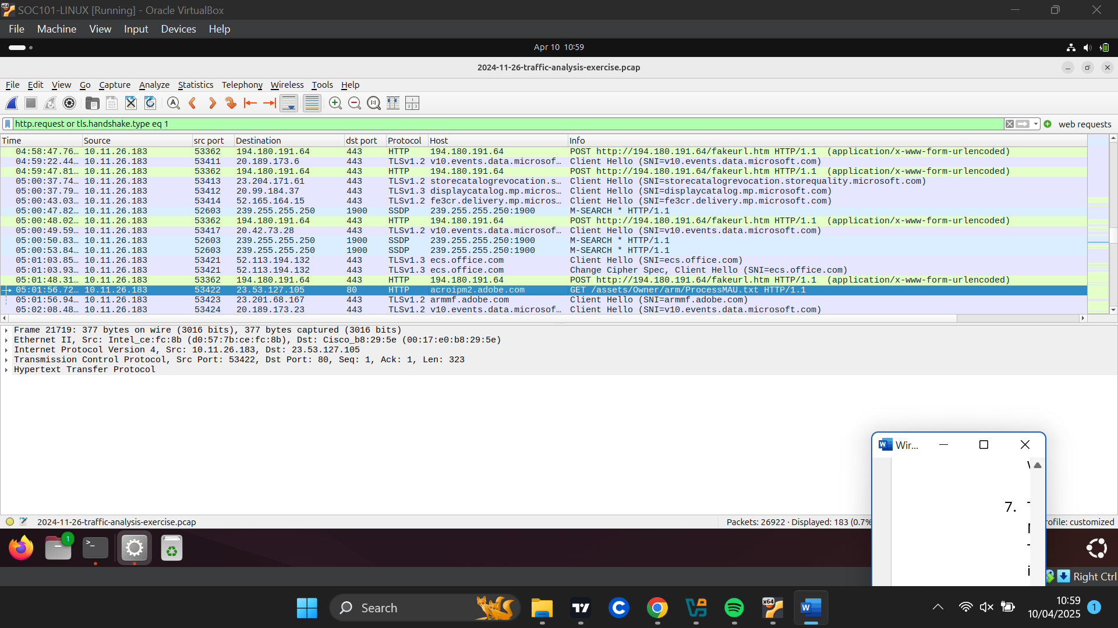
- The host then makes POST requests to the Ip address 194.180.191.64 (located in Moldova) for a fakeurl.htm file with the URL (http://194.180.191.64/fakeurl[.]htm). This IP address appeared to be malicious. The host sends lots of POST requests indicating possible data exfiltration to the C2 in sporadic nature.
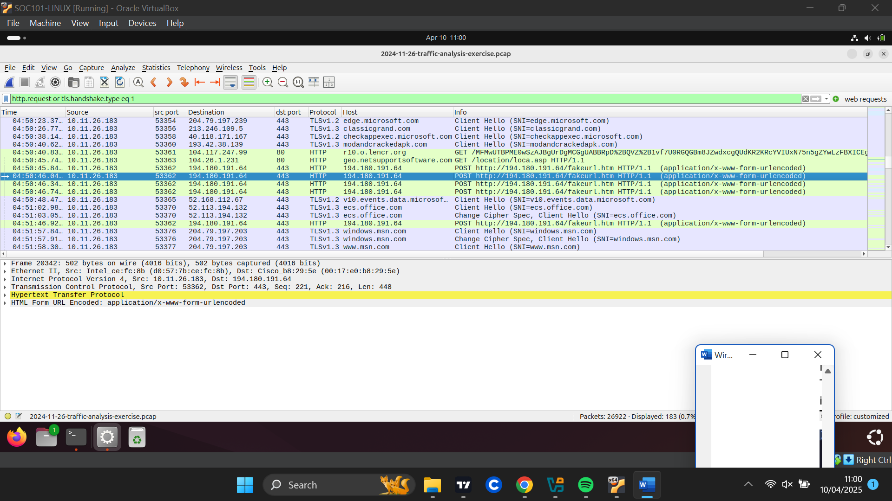
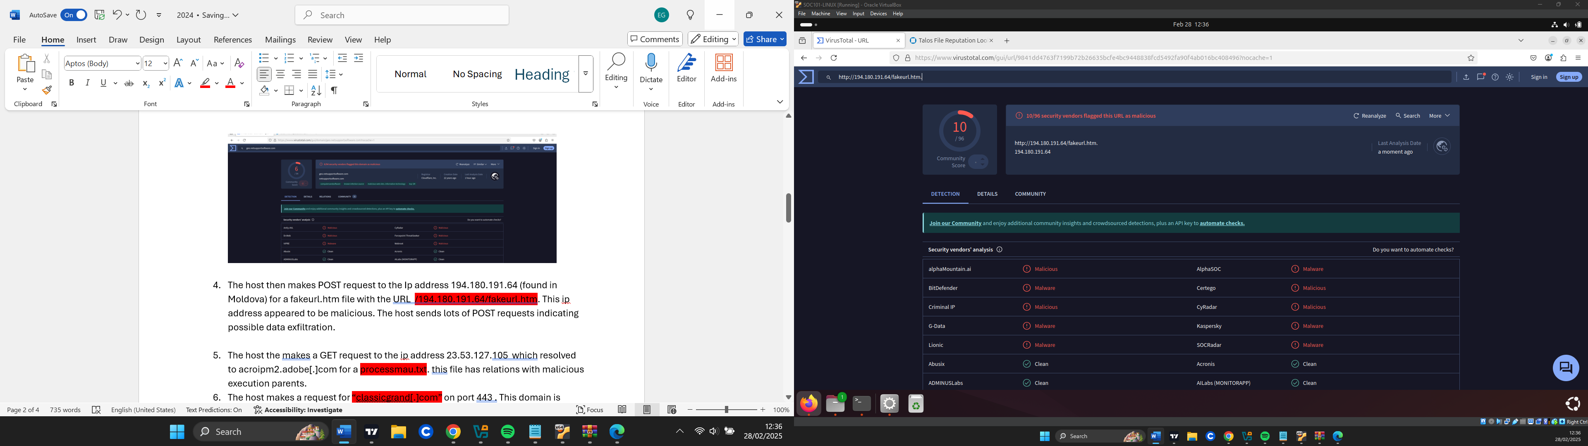

Reputation of Exported Objects:
- “Connecttest.txt” has a file hash of 5e9a7996fe94d7be10595d7133748760bf8348198b71b7a50fd8affaa980ac61 and when the reputation of this file appeared clean but has a lot of malicious execution parents making It very suspicious
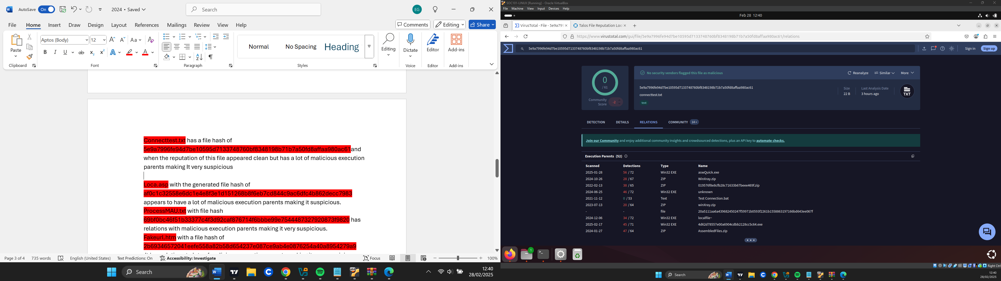

- “Loca.asp” with the generated file hash of af0c1c32558e6dc1e4e8f3e1d151268b8f6eb7cd844c9ac6dfc4b862decc7983 appears to have a lot of malicious execution parents making it suspicious.
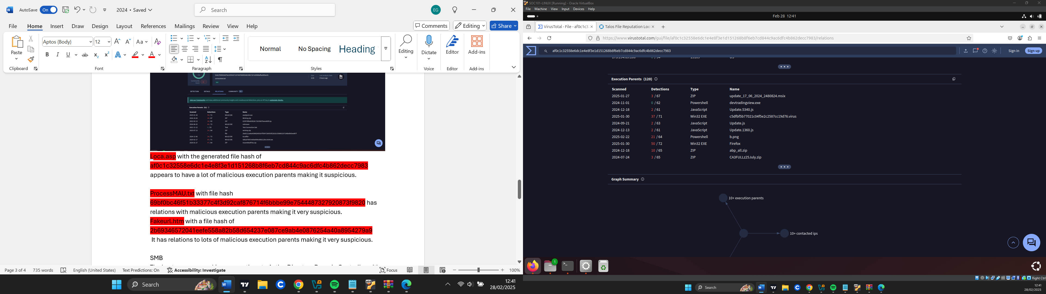

- “ProcessMAU.txt” with file hash 69bf0bc46f51b33377c4f3d92caf876714f6bbbe99e7544487327920873f9820 has relations with malicious execution parents making it very suspicious.
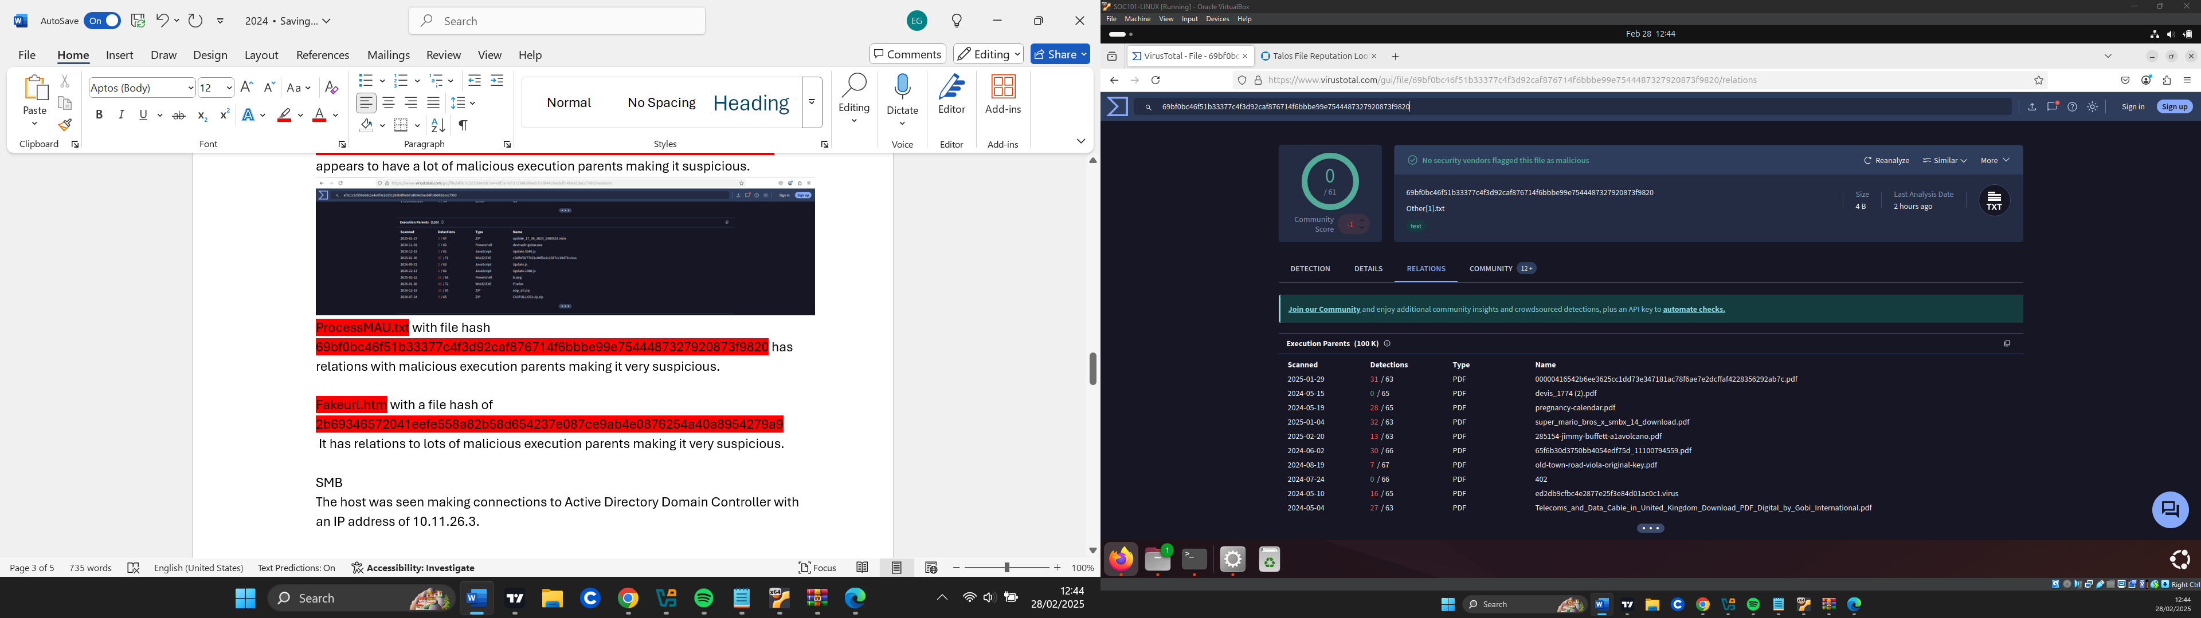

- “Fakeurl.htm” with a file hash of 2b69346572041eefe558a82b58d654237e087ce9ab4e0876254a40a8954279a9
It has relations to lots of malicious execution parents making it very suspicious.
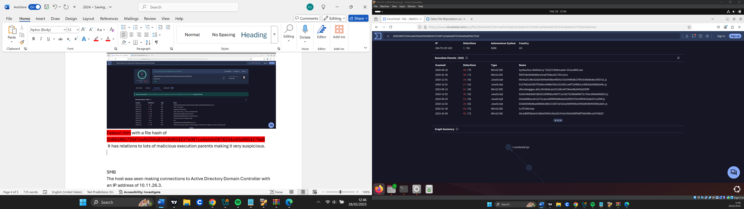

Host Identification

Using NETBIOS {filter: nbns} I found the infected Host 10.11.26.183
Mac-address: (d0:57:7b:ce:fc:8b)
Windows Hostname: DESKTOP- B8TQK49

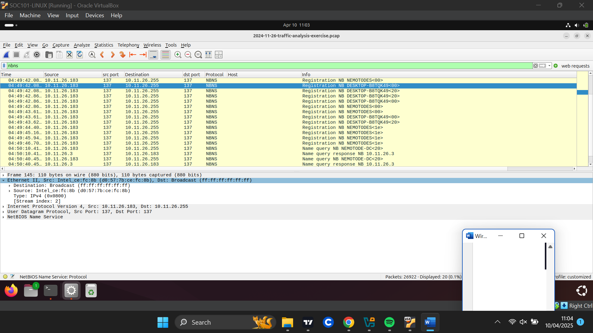

Using Kerberos {filter: kerberos.CNameString } I found the users account name in the Active Directory.
User Account Name: oboomwald
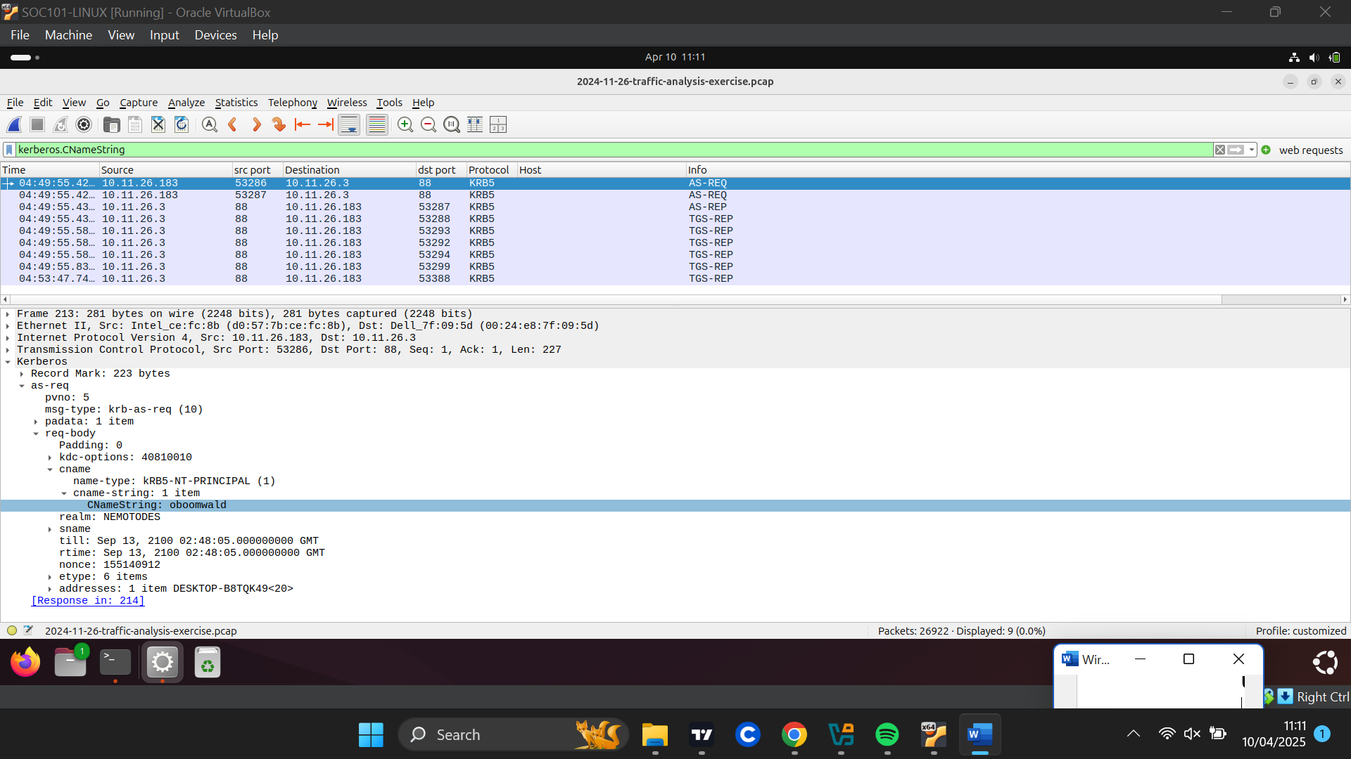

Using LDAP protocol {filter: ldap contains "CN=Users"} for the user’s full name
User’s Name: Oliver Q.Boomwald
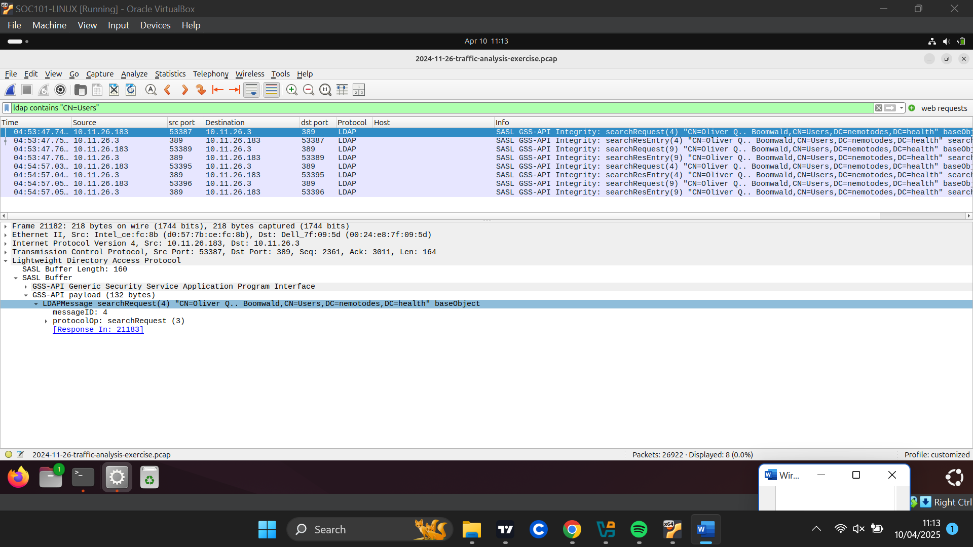

Malicious Activities observed

First, the request for the connecttest.txt file was suspicious because the file has lots of malicious execution parents.

After following on the connection between the host and “classicgrand[.]com”, Finding "classicgrand.comjj." in the encrypted message between the host and the suspicious domain "classicgrand" likely indicates a command and control (C2) communication.
This domain was found to be the second most chat with domain and there was exchange of payloads suggesting the host was infected.

After that, the host makes a request for “(modandcrackedapk[.]com)” which is a malicious site and the topmost domain in regard to bytes communicated. There was exchange of payload with this malicious site.

The host then makes a request to (geo.netsupportsoftware[.]com) for” loca.asp.” This is where NetSupportRat could have been introduced into the host because this domain is malicious.

The host makes lots of POST requests to the malicious IP address 194.180.191.64 which is suspected to be the C2.
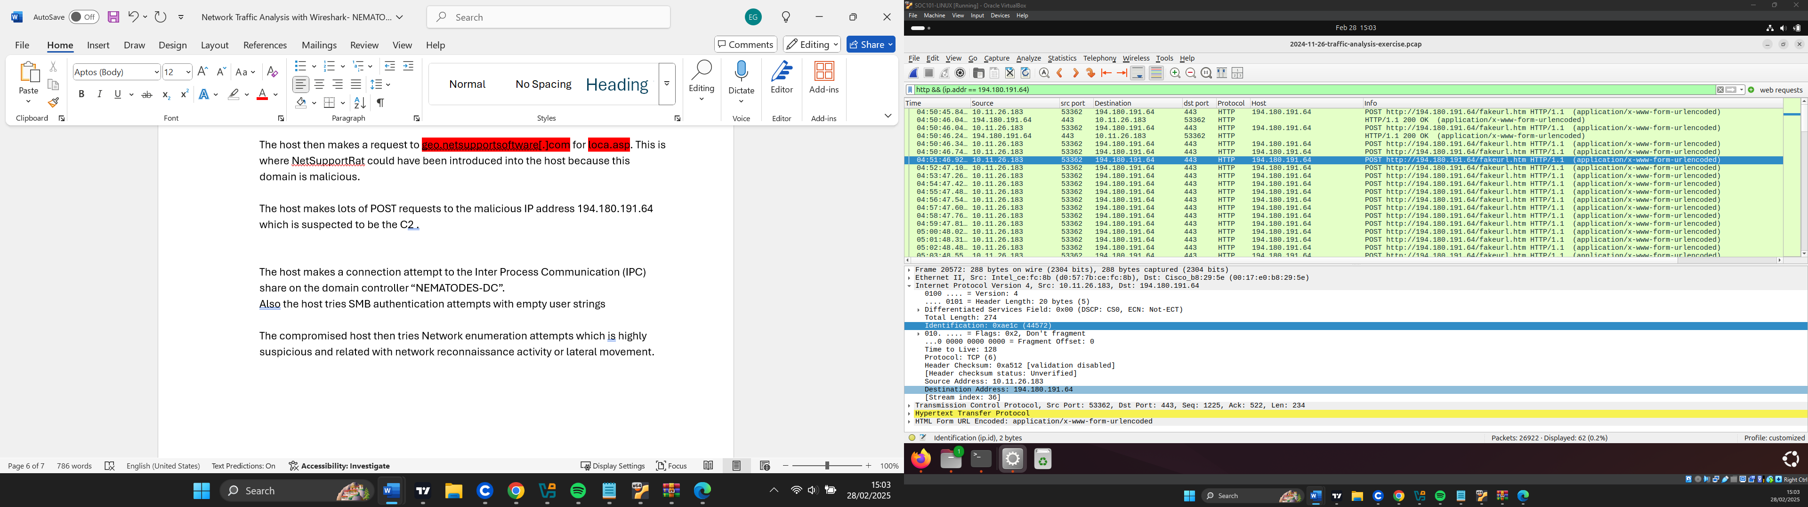

The compromised host makes a connection attempt to the Inter Process Communication (IPC) share on the domain controller “NEMATODES-DC”. This type of SMB request indicates potentially suspicious or malicious reconnaissance activity. Inter-Process Communication share is a special administrative share that doesn't correspond to a physical disk location. Instead, it facilitates named pipe communication for remote procedure calls (RPCs) between computers on the network.
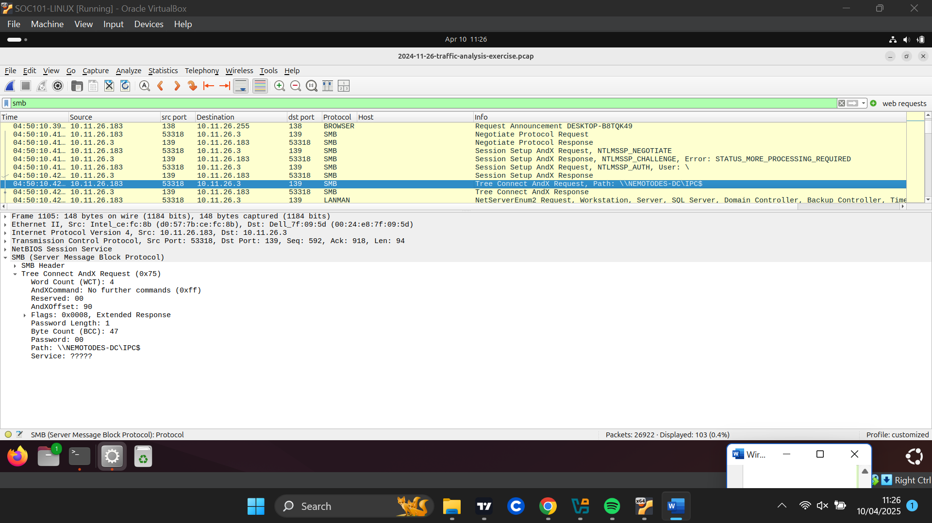
Also, the host tries SMB authentication attempts with empty user strings

The compromised host then tries Network enumeration attempts which is highly suspicious and related with network reconnaissance activity or lateral movement.
